

OGAM
Metadata Architecture

Contents

1 Introduction 3
2 Metadata Structure 4
2.1 Description of the datasets used for importation 5
2.2 Description of the datasets used for consultation 6
2.3 Description of the database storage structure 7
2.4 Description of the nomenclature 9
2.5 Description of the importation system 12
2.6 Description of the consultation forms 13
2.7 Check rules 15
3 Data types correspondence 16

Introduction

This document describes the architecture of the metadata structure of the project.

For a description how the metadata are used in the application, see the “Metadata – Use Cases” document.

For a description of how to fill the metadata tables, see the “Administrator Manual” document.

The purpose of OGAM platform is to manage a geo-referenced information system defined by the end user. To do so, the application has to dynamically discover the data to be used and to carry out all the SQL queries without knowing the structure of the database.
Consequently, the OGAM platform uses a powerful and generic metadata database to store information about the data.
The platform is currently composed of different modules such as an importation module and a module to carry out queries. The metadata database proposes also different tables to store information about the file to transfer and the forms to be screened.

Thank to its flexibility, this model can be extended to manage and feed new modules.

Metadata Structure

Here is the complete conceptual model of the metadata database

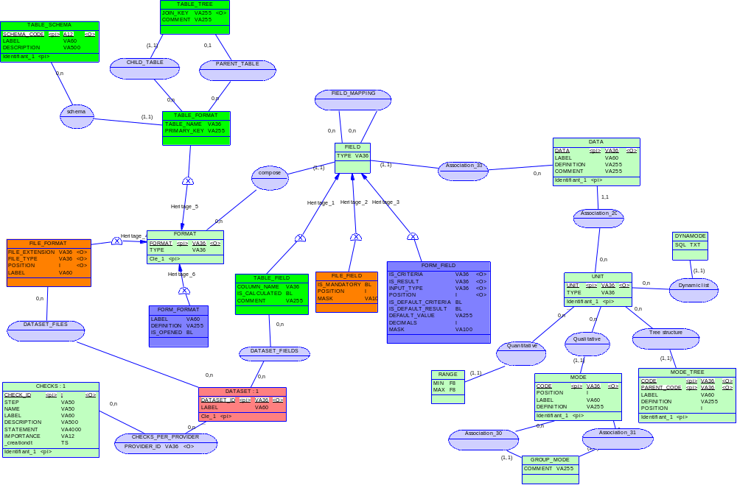

Each colour is dedicated to a specific meaning:
- The red colour represents the top level table to store the dataset (the information system to manage).
- The light green colour represents the metadata model for storing the nomenclature and the physical implementation.

Each implementation uses the following colours:
- tables represented in bright green colour
- html forms represented in blue colour
- files to import represented in orange colour

To be extensible, the metadata is based on heritage between table. That is why the metadata uses the generic notion of a format grouping fields in different contexts.

The FIELD table is never really used alone, it is a parent table for the FORM_FIELD, TABLE_FIELD and FILE_FIELD tables (it ensures the unicity of the fields).

Same thing for the FORMAT table, it is a parent of the FORM_FORMAT, TABLE_FORMAT and FILE_FORMAT tables.

Description of the datasets used for importation

The dataset is the main entry point when using the application metadata.

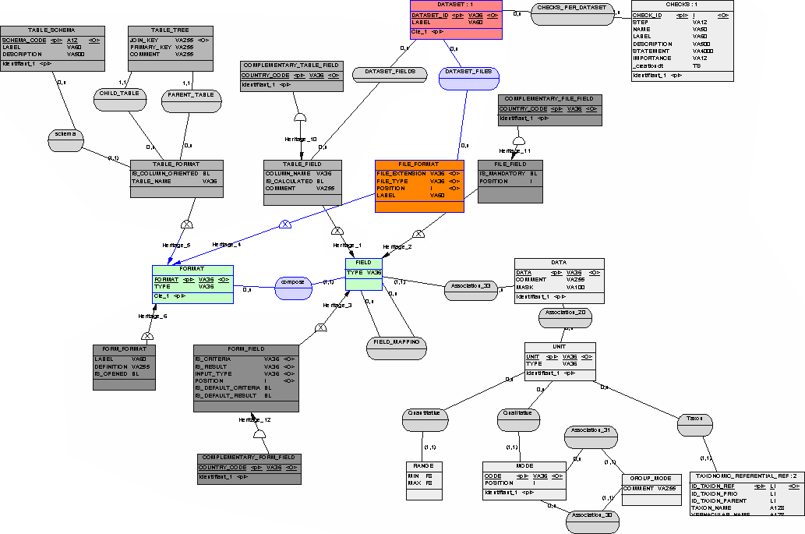

A dataset represents a part of a geo-referenced information system to manage. It can correspond to all the fields needed for a study or a given protocol.

When used for importation, the dataset is described as a set of file formats.

Dataset
Field | Description
DATASET_ID | The logical name of the dataset
LABEL | The label of the dataset
IS_DEFAULT | Indicate if the dataset is selected by default (only 1 possible)
DEFINITOIN | The definition of the dataset (used in tooltips)

Dataset_Files
Field | Description
DATASET_ID | The logical name of the dataset
FORMAT | The file format associed with the dataset (used when importing data)

Description of the datasets used for consultation

The dataset is the main entry point when using the application metadata.

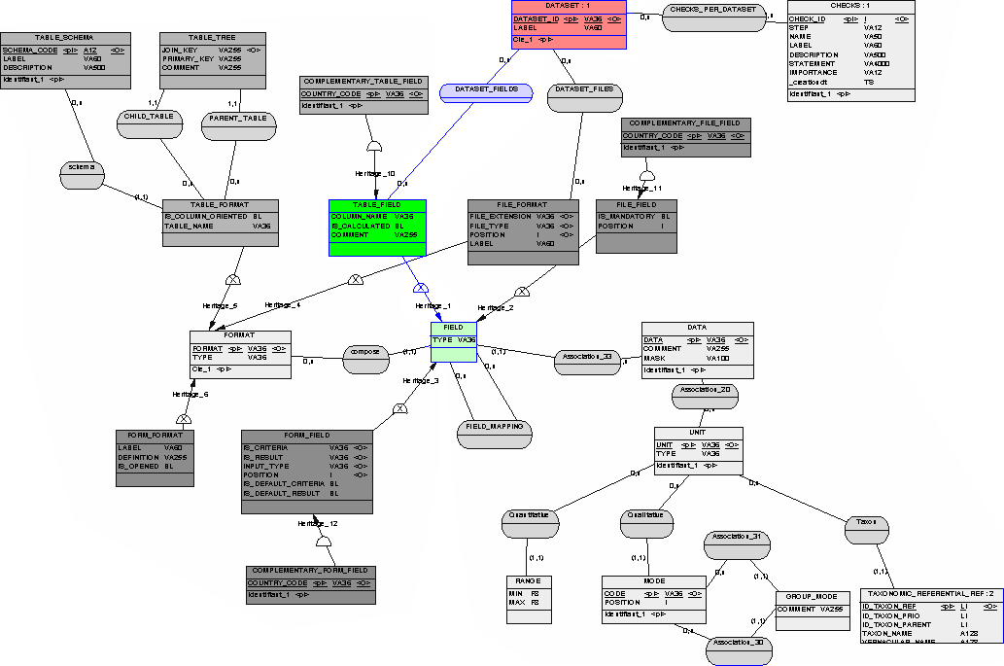
A dataset represents a part of a geo-referenced information system to manage. It can correspond to all the fields needed for a study or a given protocol.

When used for consultation, the dataset is described as a set of fields that are stored in the database (table fields). These fields can be mapped with some form fields thru the field_mapping table.

Note : The dataset_fields can be linked to different sets on table fields, depending on the schema. For example, the fields that are displayed for the raw data are not always the same as for the harmonized data.

Note 2 : The link between the a dataset and a list of table fields can be done thru the “table field” table (consultation path) or thru the “file_format” table (insertion path). We are not in a normal form. This is done intentionally, some fields can be stored and never displayed and some displayed fields can have been calculated and never imported.

Dataset
Field | Description
DATASET_ID | The logical name of the dataset
LABEL | The label of the dataset
IS_DEFAULT | Indicate if the dataset is selected by default (only 1 possible)
DEFINITOIN | The definition of the dataset (used in tooltips)

Dataset_Fields
Field | Description
DATASET_ID | The logical name of the dataset
SCHEMA_CODE | The code of the schema
FORMAT | The table format associed with the dataset
DATA | The table field associed with the dataset (used when querying data)

Description of the database storage structure

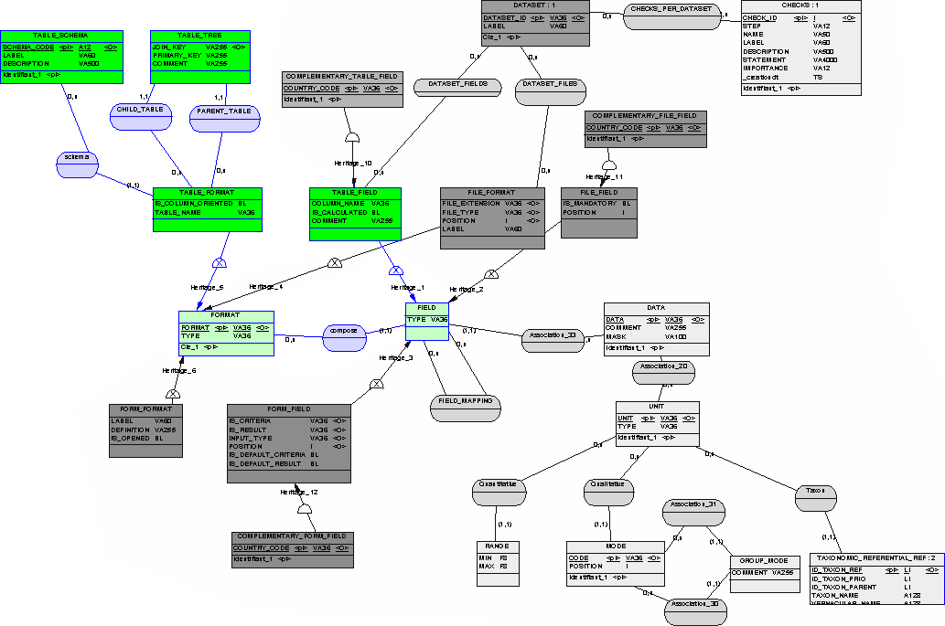

The description of the database structure is a mandatory part of the administration of the metadata. It is a prerequisite for all the modules of the project.

The description of the storage structure is pretty simple, it correspond to the list of tables and columns that will contain the data.

The TABLE_SCHEMA table contains the name of the schema where the tables are stored.
Field | Description
SCHEMA_CODE | The code of the schema
SCHEMA_NAME | The name of the schema (name in the database)
LABEL | The label of the schema
DESCRIPTION | The description of the schema

The TABLE_FORMAT table contains the list of tables used.
Field | Description
FORMAT | The logical name of the table
TABLE_NAME | The physical name of the table
SCHEMA_CODE | The code of the schema
PRIMARY_KEY | The list of table fields used to identify one line of the child table (separated by commas)
LABEL | A label for the table (displayed on the detail panel)

The TABLE_FIELD table contains the list of columns for each table.
Field | Description
DATA | The logical name of the field
FORMAT | The logical name of the table format containing this field
COLUMN_NAME | The physical name of the column
IS_CALCULATED | Indicate if the field should be provided for insertion (value = 0) or if it is calculated by a trigger function (value = 1)
IS_EDITABLE | Indicate if the field can be edited in the edition module. Some fields calculated by trigger may be useless on the screen.
IS_INSERTABLE | Indicate if the field can be added thru the edition module. Some field can be displayed when updating but not when inserting a new data (for example, calculation of a “department” by trigger).
IS_MANDATORY | Indicate if the field is mandatory in the edition module. Primary keys are always mandatory.
POSITION | The position of this field in the table (for the detail panel and the edition module)
COMMENT | Any comment

The TABLE_TREE table contains the description of the hierarchical structure of the tables and the foreign keys used to join them.
Field | Description
SCHEMA_CODE | The code of the schema
CHILD_TABLE | The logical name of the child table
PARENT_TABLE | The logical name of the parent table
JOIN_KEY | The list of table fields used to make the join between the tables (separated by commas)
COMMENT | Any comment

Note : This information could also have been extracted from the system tables of PostgreSQL. But in order to keep the system simple and maintainable we have chosen to add this information in the metadata tables.

After this first step, the application is able to carry out all the SQL requests with pertinent jointure.

Description of the nomenclature

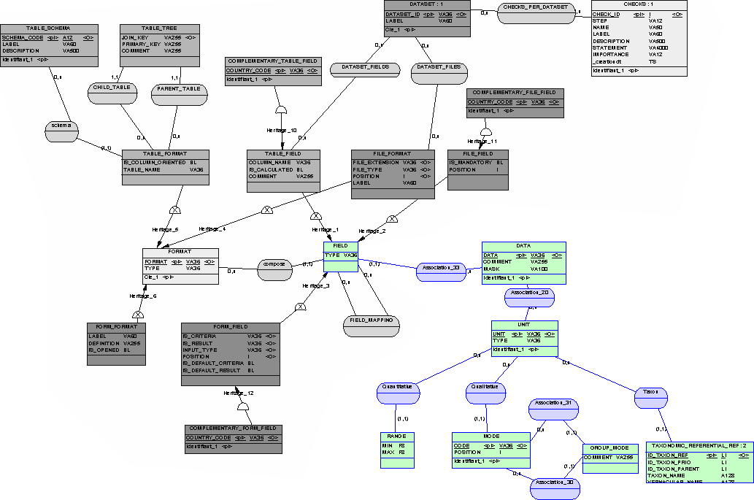

The description of the nomenclature is another mandatory part of the metadata administration.

In order to manage the data previously described, we need to add some extends to the metadata model.
To be fully generic, each data is linked to a logical data entity. This data entity is linked to a unit and this unit can be of different types such as qualitative variable, quantitative variable, species, …

The DATA table describes the abstract data entity and link it to a unit.
Field | Description
DATA | The logical name of the data
UNIT | The unit of the data
LABEL | The label of the data
DEFINITION | The definition of the data (used in tooltips)
COMMENT | Any comment on the data

The UNIT table list available units.

The unit type can be chosen in the following list :
- STRING : A simple string.
- INTEGER : An integer.
- NUMERIC : Any numeric value.
- DATE : A date.
- BOOLEAN : A Boolean
- CODE : A code selected from a list of authorised codes.
- ARRAY : A list of codes.
- GEOM : A geometry
- IMAGE : An image

For the data having a unit of type CODE, the MODE table list the available codes.
For the data having a unit of type RANGE, the RANGE table defines the MIN and MAX values of the range.

Field | Description
UNIT | The unit
TYPE | The type of the unit
SUBTYPE | The subtype of the unit. Defines the table where to find the list of available values for codes.  Can be MODE, TREE, TAXREF or DYNAMIC for CODE and ARRAY.  Can be RANGE or COORDINATE for numeric.  Can be POINT, LINESTRING or POLYGON for GEOM.
LABEL | The label of the unit
DEFINITION | The definition of the unit

The MODE table list the available modes for a unit.
Field | Description
UNIT | The unit
CODE | The code
POSITION | The position of this mode in the list
LABEL | A label for the code
DEFINITION | The definition of the mode

The RANGE table list the acceptable range for a range unit.
Field | Description
UNIT | The unit
MIN | The minimal value of the range
MAX | The maximal value of the range

The GROUP_MODE table allow us to do a mapping between different sets of codes.
Field | Description
SRC_UNIT | The source unit
SRC_CODE | The source code
DST_UNIT | The destination unit
DST_CODE | The destination code
COMMENT | A comment

The MODE_TREE table allow us to do describe a hierarchical structure of codes.
Field | Description
UNIT | The unit
CODE | The code of the item
PARENT_CODE | The code of the parent of the item (-1 for the root node)
LABEL | The label
DEFINITION | The description of the item
POSITION | The position for nodes of the same level
IS_LEAF | Indicate if the node is a leaf (1 for true)

The MODE_TAXREF table allow us to do describe a hierarchical structure of taxonomical references.
Field | Description
UNIT | The unit
CODE | The code of the item
PARENT_CODE | The code of the parent of the item (-1 for the root node)
NAME | The short name of the taxon
COMPLETE_NAME | The complete name of the taxon (name and author)
VERNACULAR_NAME | The vernacular name
IS_LEAF | Indicate if the node is a leaf (1 for true)
IS_REFERENCE | Indicate if the taxon is a reference (1) or a synonym (0)

The DYNAMODE table allow us to dynamically build a list of modes.
Field | Description
UNIT | The unit
SQL | A SQL query that should return an ordered list of CODE, LABEL, DEFINITION

Description of the importation system

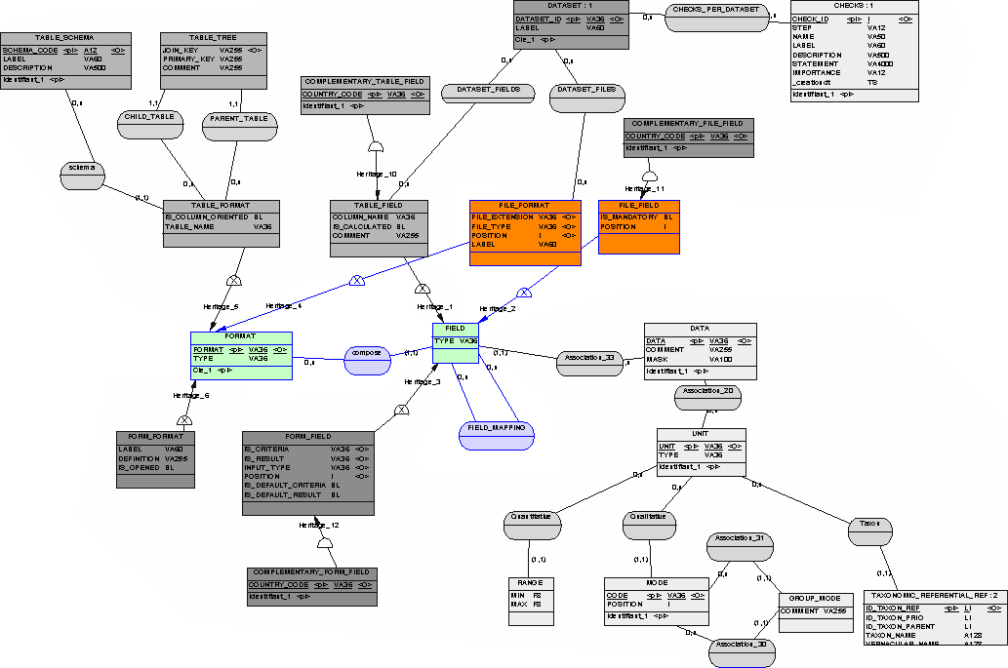

The description of the importation system in the metadata is optional. It is needed when the generic importation module is used.

The generic importation module use the description of some CSV Files to read them and then use the mapping between fields to store the read values in the database.

The FILE_FORMAT table contains the definition of the CSV files linked to the dataset to import.
Field | Description
FORMAT | The logical name of the format
FILE_EXTENSION | The extension of the file
FILE_TYPE | An identifier of the type of file (used to identify the file during the upload process)
POSITION | The position of the file in the upload screen
LABEL | The label associed with the file in the upload screen

The FILE_FIELD table contains the list of fields of each file. It indicates the position of the field in the CSV file and if it is mandatory or not.
Field | Description
DATA | The logical name of the field
FORMAT | The logical name of the file format containing this field
IS_MANDATORY | Indicate if the field is mandatory (1 for true)
MASK | A mask used to validate the data
POSITION | The position of this field in the file

The FIELD_MAPPING table does the mapping between the file fields and the table fields.
Field | Description
SRC_DATA | The source data
SRC_FORMAT | The source format
DST_DATA | The destination data
DST_FORMAT | The destination format
TYPE | The type of mapping (FORM, FIELD)

Description of the consultation forms

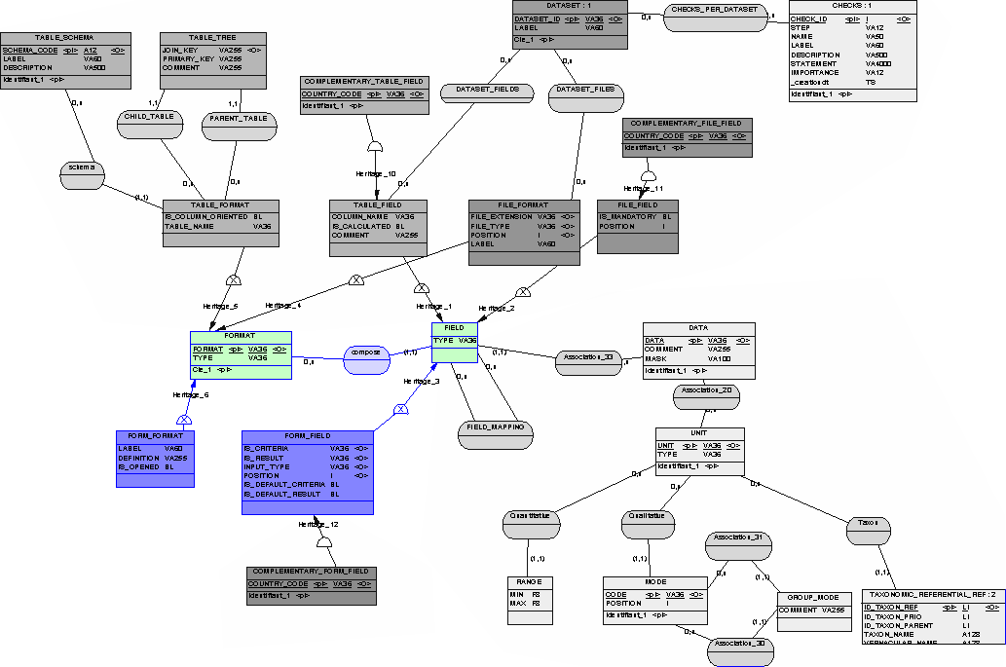

The description of the user interface forms in the metadata is optional. It can be used by the generic consultation module to generate the HTML Forms that are displayed on the web site. It could also be used by a module to fill the different forms to create or modify the records of each data tables.

The FORM_FORMAT table describes the list of formats that are shown on the consultation page. A form format is a logical group of fields. For simplicity, a form format often corresponds to all the fields of the same table.
Field | Description
FORMAT | The logical name of the format
LABEL | The label of the form displayed in the query screen
DEFINITION | The definition of the form
POSITION | The position of the form in the query screen
IS_OPENED | Indicate if the form is displayed as opened by default

The FORM_FIELD table describes the list of fields of a form.

Field | Description
DATA | The logical name of the field
FORMAT | The name of the form format containing this field
IS_CRITERIA | Can this field be used as a query criteria?
IS_RESULT | Can this field be displayed as a result?
INPUT_TYPE | The input type associed with this field (TEXT, DATE, GEOM, NUMERIC, SELECT)
POSITION | The position of this field in the form
IS_DEFAULT_CRITERIA | Is this field selected by default as a criteria?
IS_DEFAULT_RESULT | Is this field selected by default as a result?
DEFAULT_VALUE | The default value
DECIMALS | The number of decimals to be displayed (for numbers)
MASK | In input Mask (for dates)

Each field have an input type and can be (or not) displayed as a query result or criteria.

The available input types are the following :
- TEXT (a simple input text field).
- SELECT (a combobox).
- DATE (a date picker).
- GEOM (a spatial tool with polygon intersection).
- NUMERIC (a range picker).
- CHECKBOX (a checkbox)
- TREE (a tree view)
- IMAGE (an image)

As before, the FIELD_MAPPING table does the mapping between the form fields and the table fields (see description above).

NOTE : When importing the metadata, a procedure is run to verify that the form input type is consistent with the corresponding data type (a date input field should correspond to a date in database).

NOTE : The DEFAULT_VALUE is used when a new form field is created for data edition.
If DEFAULT_VALUE is ‘%TODAY%’ then the current date is set.
If DEFAULT_VALUE is ‘%LOGIN%’ then the login of the current user is set.

Check rules

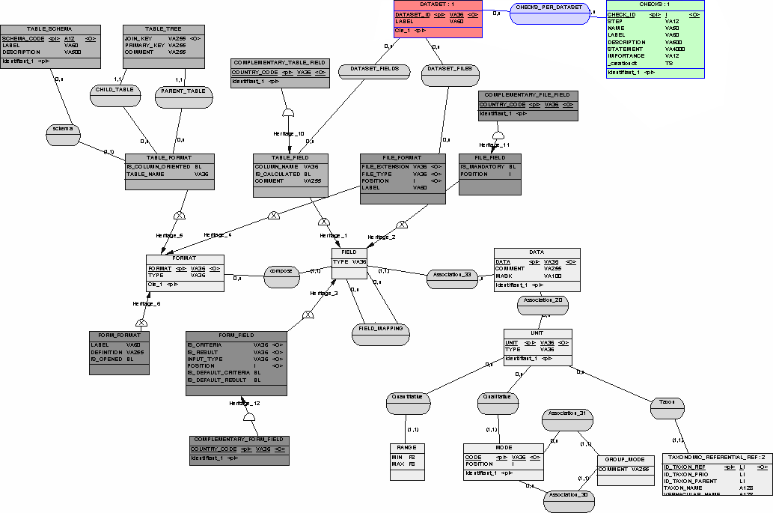

The OGAM platform gives the opportunity to run some checks on the inserted data.

The data is automatically checked for compliance with its definition during the importation or creation (check that the codes are in the list of authorised codes, …).

After these first checks, more advanced conformity tests can be run. These checks have to be considered as a knowledge database. These check or cross checks are in fact some SQL statements that are launched on the inserted dataset.

The CHECKS table contains the definition of these checks.
Field | Description
CHECK_ID | The identifier of the check
STEP | The step of the check (COMPLIANCE or CONFORMITY)
NAME | The name the check
LABEL | The label of the check
DESCRIPTION | The description the check
STATEMENT | The SQL statement corresponding to the check
IMPORTANCE | The importance of the check (WARNING or ERROR)
_CREATIONDT | The creation date

The name, the label and the description of the checks are used when we generate a PDF report about the submission.
The importance of the check defines if the error is blocking for the submission (ERROR) or not (WARNING).

Data types correspondence

We describe here the mapping between a unit type, the expected corresponding form type for display and the SQL type for storage.

See “Data types.ods” for more details

Unit Type | Unit Sub-Type | Form Type | SQL Type
STRING |  | TEXT | TEXT or VARCHAR(n)
INTEGER |  | NUMERIC | INT
NUMERIC |  | NUMERIC | FLOAT or NUMERIC
NUMERIC | RANGE | NUMERIC | FLOAT or NUMERIC
NUMERIC | COORDINATE | NUMERIC | FLOAT or NUMERIC
DATE |  | DATE | DATE
GEOM |  | GEOM | GEOM
GEOM | POINT | GEOM | POINT
GEOM | LINESTRING | GEOM | LINESTRING
GEOM | POLYGON | GEOM | POLYGON
BOOLEAN |  | CHECKBOX | CHAR(1)
CODE | MODE | SELECT | VARCHAR(36)
CODE | DYNAMIC | SELECT | VARCHAR(36)
CODE | TREE | TREE | VARCHAR(36)
CODE | TAXREF | TAXREF | VARCHAR(36)
ARRAY | MODE | MULTIPLE | TEXT[]
ARRAY | DYNAMIC | MULTIPLE | TEXT[]
ARRAY | TREE | TREE | TEXT[]
ARRAY | TAXREF | TAXREF | TEXT[]
IMAGE |  | IMAGE | TEXT or VARCHAR

A CODE is a selection of one item in a list of possible values (represented by a select box).

An ARRAY is a selection of multiple items in a list a possible values (represented by a select box with multiple choices).

A CODE or an ARRAY list of items can be populated using the MODE table, the DYNAMODE table or the MODE_TREE trable.

